Final Project Design Phase
Computer Science - Week 11
Oct 3, 2026 - Version 0.0.4

For complete instructions and project ideas, refer to the assignment in Canvas. Specifically, review the final project requirements before you continue below. If you have not reviewed the project requirements in Canvas (you might have to go to the modules view and check the current or past week's content), you will not be able to properly complete the parts below. In addition, it may be helpful to review the information on this Drafter documentation page.

0) Project Planning and Preparation
Successful programmers spend time planning before they begin coding. After reviewing the project requirements, answer the following questions to help guide your design and development process.
- What concepts from class or previous assignments might help you complete this project? Which programming concepts (loops, conditionals, lists, classes, etc.) do you expect to use? What programming skills do you want to improve while completing this project?
A lot of the loops will help me to find different operations in the problems. I want to improve my drafter use as a whole during this project, because web applications are used almost everywhere. Being more comfortable with them is helpful no matter what I do in the future.

- Which parts of the project do you expect to be the easiest for you? The hardest? Why?
The easiest part for me is definitely brainstorming and designing the project. I have a clear idea of what I want to do and how I want it to look already, because I love math. The hardest part is confirming I have all of the code correct and working how I want. I’m not the strongest coder and get overwhelmed easily.

- Even though you have not yet designed the final project, estimate which tasks will likely require the most time and effort? Which features or components should be implemented first?
The most time and effort will be making sure I have all the information on the technique pages that will sufficiently help the user. The first features that should be implemented is the home page that the user will input into and will return the suggested technique, because it will be the most interactive and involved part coding wise.

- What distractions might interfere with your work and how will you minimize them? What resources will you need available while working? What questions, if any, do you still have about the assignment requirements?
I go to work a lot, so it’s not a distraction but it takes away 20-30 hours a week that I have to focus on school. I can minimize it by expediting some of the process where I’d naturally want to work on it myself, an LLM can check my work and write parts I get stuck on that I can check, or double check I met requirements just to save time. The resources I have are my TA’s and instructors who know a lot more about computer science than me, my peers, and LLM. I don’t have any specific questions.

1) Site Diagram
Create a mock-up of your planned website. We suggest you make the mockup on paper, although you can also use software like PowerPoint or Slides to make a mockup. There is other design software that could also be used, but we strongly encourage you to keep it simple. Do not spend more than 15-30 minutes detailing the mock-up. Your goal should be to make a very quick and dirty diagram, to show that you have some kind of idea.

We recommend drawing each page as a rectangle, and laying out the text, buttons, and other components inside. Then, use arrows to indicate links between pages. Label each page the way you will name each function, and then put labels on the arrows to indicate what the button links. Also write down any parameters that should come into the pages.

In addition to the pages and routes, write down what fields your `State` will have, both their names and types. Think clearly about what data will need to be persistent across the entire website.

Add photo(s) or screenshot(s) of your website mock-up and labeled diagram on the next page.

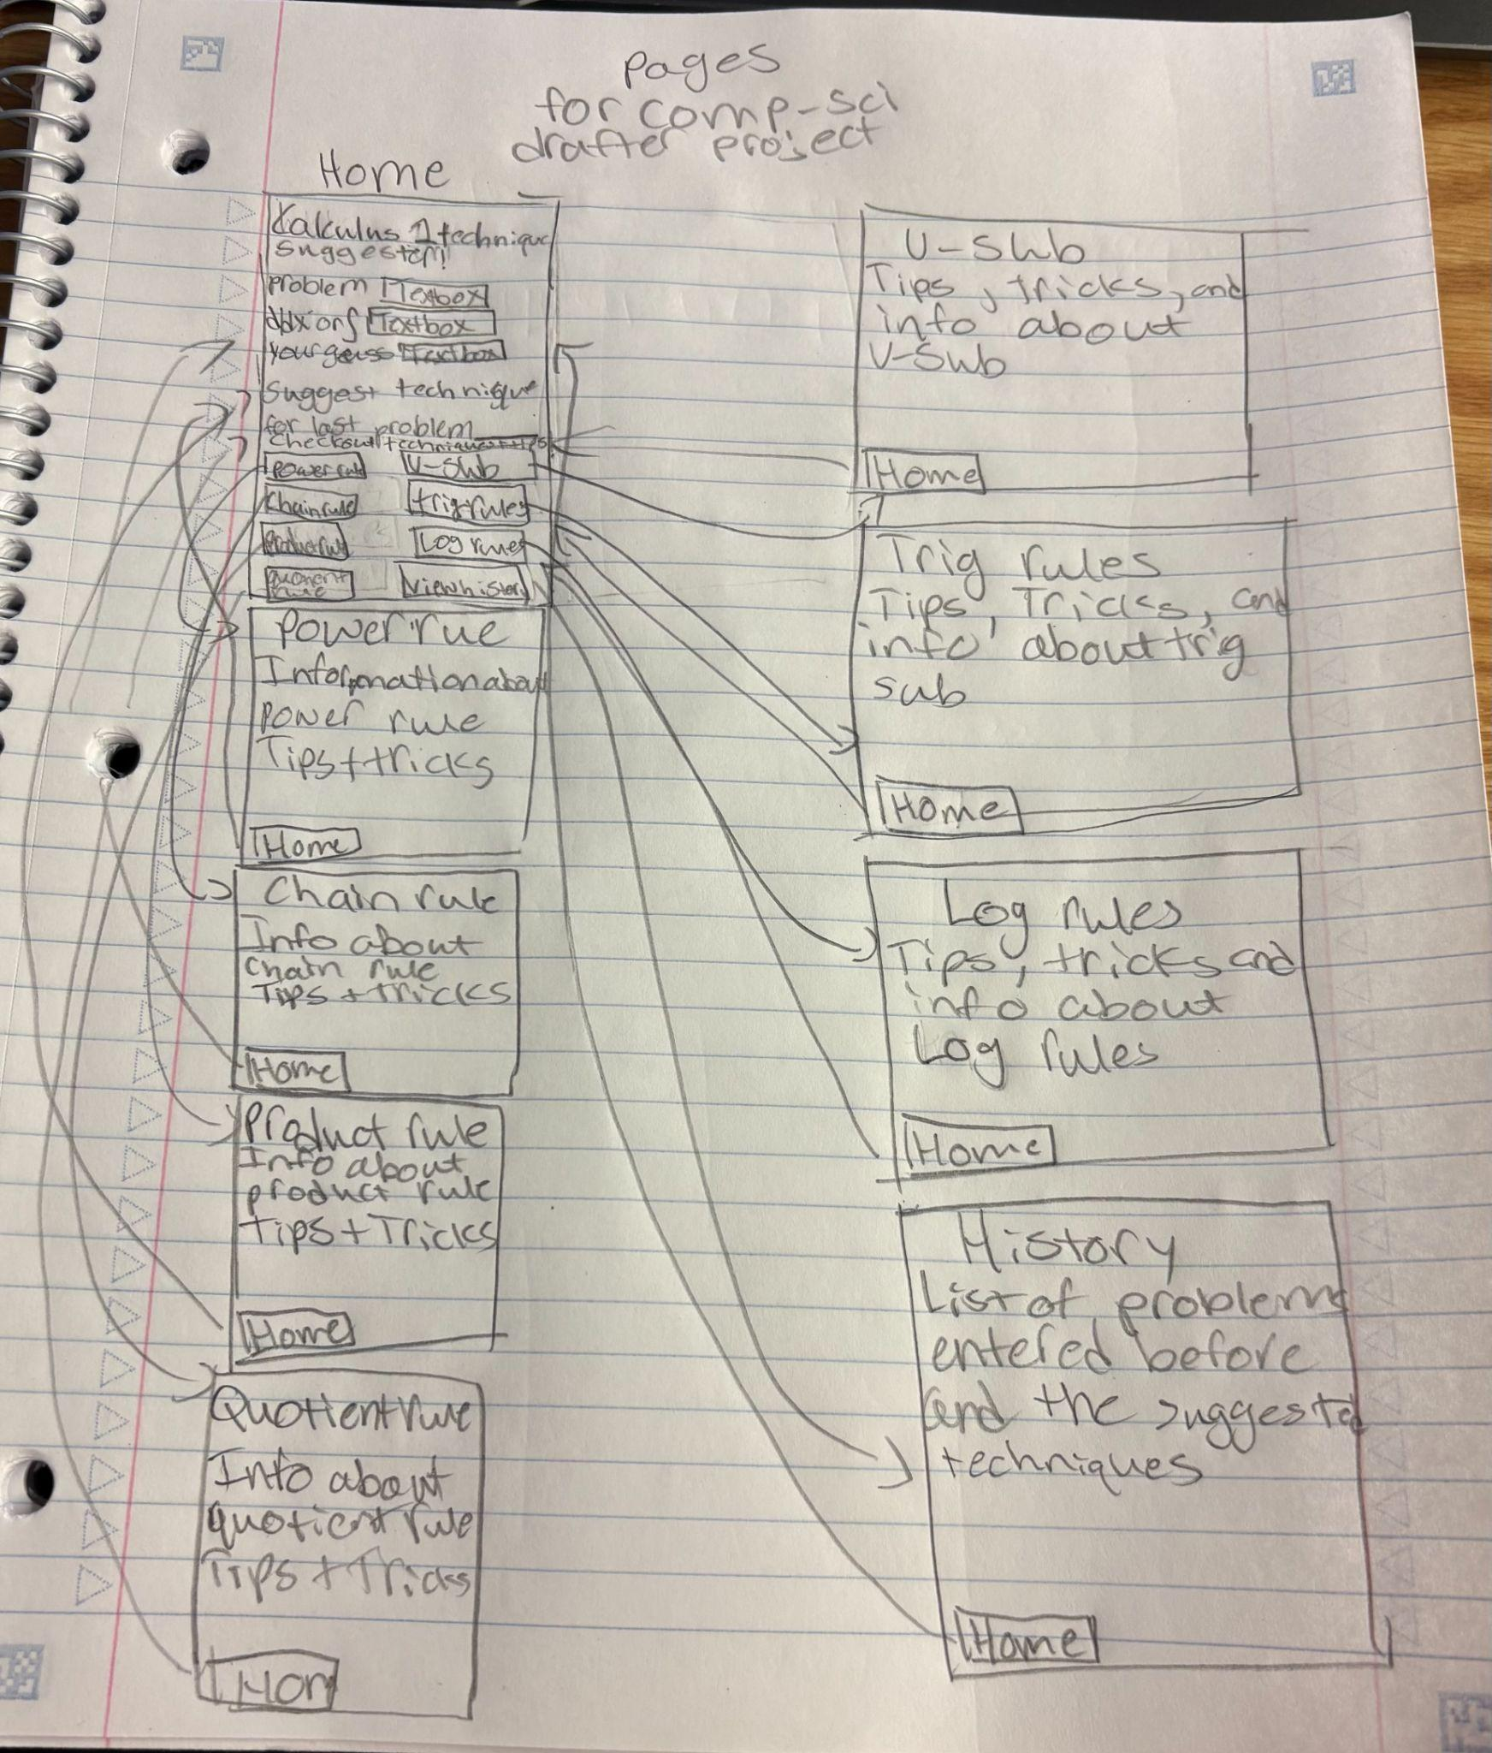
2) Implementing Requirements
This table should serve as a draft for how you will implement the requirements into your final project. You may change your ideas later on, but your final site must fulfill all the requirements.

Requirement | Implementation
Purpose/Functionality  A 1-2 sentence description of the purpose or functionality of your site | The purpose of my site is to help make calculus slightly easier for students without doing it for them. That way they can get help and learn without as much frustration.
State Dataclass Attributes  Minimum of 4 attributes, one of which must be a list/dict of instances of your second dataclass.  Briefly describe each attribute, its type, and how it will be meaningfully modified throughout the site. | The attributes will be  user_attempts: list[MyAttempt]  - This is a history of the previous problems the user has tried, and will be added to every time the user enters a new problem  new_problem: str  - This is the current problem they’re trying to find a technique for and will be a new input for every problem they want to try  differentiation_or_integral: str  - This will allow the user to choose whether the problem is an integral or a differentiation. This will be input every time the user wants a technique.  suggested_technique:  - This is the application's suggestion for the technique the problem will use based on the information the user input.
Second Dataclass  Your second dataclass, including its attributes, their types, and how they will be meaningfully modified (if they are modified) | MyAttempt  problem: str  - This is the calculus problem that the student will input to find a technique for. Will be input every time the student wants the technique.  operation: str  - This is the student inputting whether the problem is differentiation or integration and will be put in for every problem  My_guess: str  - This is the technique the student thinks is going to be used for the problem, to see how it compares to the right technique
Routes (minimum 7)  The names of your route functions | - index  - select_operation  - submit_problem  - suggest_technique  - power_rule  - chain_rule  - product_rule  - quotient rule  - u_sub_rule  - trig_rules  - exponential_log_rules  - view_history
Pages (minimum 5)  A brief description of the pages in your site | - Home page- Where all information is inputted into, to help the user get a technique.  - Power rule page- Displays information about power rule in depth for differentiation and integrals.  - Chain rule page-Displays information about chain rule in depth for differentiation and integrals.  - Product rule- Displays information about product rule in depth for differentiation only since this is calc 1 focused.  - Quotient rule- Displays information about quotient rule in depth for differentiation only since this is calc 1 focused  - U-sub rule- Displays information about the u-sub rule in depth for integrals.  - Trig rules- Tips and tricks for when the user sees trig properties in their problems  - Exponential logs- Shows tips and tricks for exponential logs in problems  - History page- To show what the user has input and tried before.
User Input (minimum 3)  Description of user input components (TextBox, TextArea, CheckBox, or SelectBox) and their purposes  For more information on these input types, see Drafter Documentation. | There will be a text box to let the user input their problem, their guess, and if it’s d/dx or integration. There will also be a select box for them to choose what technique they think is going to be used, so they can test their own knowledge while still getting the help they need.
If Statements (minimum 3)  Brief description of what will be evaluated in your if statements and how they will meaningfully change the logic of the site | I will have if statements to evaluate if a problem has multiplication, division, bounds, and powers.
Loop (minimum 1)  This loop must iterate over the list/dict of dataclass instances in your State attribute.  Description of this loop and why it is meaningful to the site | My loop will be over the characters in a string to see what symbols are used within the problem. This is meaningful because it helps narrow down what technique may be used.

LLM Conversation
If you used an LLM in any part of this work, copy and paste every part of that conversation below. Otherwise, you may be given a zero for the assignment. Obviously, these words will not all be yours, and this is the exception to the requirement at the top of this assignment that all responses be in your own words. If you did not use an LLM to assist you in this assignment, simply say so below.
I have a computer science project and part of the requirements are confusing me. what does this mean simply
- The implementation of the State dataclass must have at least 4 fields.
  - At least one field must be a list of class instances or a dictionary of class instances.
    - This means that there must be a second dataclass.
  - At least 4 state fields, including the list or dictionary of class instances, must each be meaningfully modified in at least one route; those 4 state fields cannot be constants.
Basically, your professor wants you to create a program that stores information using at least two dataclasses and allows the user to change that information.
Let's break it down.

1. Your State dataclass must have at least 4 fields.
A field is just a variable inside your dataclass.
For example:
@dataclass
class State:
name: str
score: int
level: int
items: list
Here, you have 4 fields:
- name
- score
- level
- items

2. At least one field must be a list or dictionary of class instances.
This means you need to create a second dataclass.
For example:
@dataclass
class Item:
name: str
price: int
Then your State dataclass could contain:
@dataclass
class State:
name: str
score: int
level: int
items: list[Item]
Notice that items is a list containing instances of your Item dataclass.

3. At least 4 state fields must be meaningfully modified in a route.
This is probably the most confusing requirement.
A route is a function in your application that handles something the user does, such as clicking a button.
Your professor wants at least 4 of your State fields to actually change when the user interacts with your program.
For example:
State field | How it could change
name | User enters a new name
score | User earns points
level | User completes a level
items | User adds an item to their list
Important: Just having four fields isn't enough. Your program must actually modify all four of them somewhere in your routes.
Also, you cannot use constants (values that never change) to meet this requirement.

In simpler terms, your checklist is:
- Create a State dataclass.
- Give it at least 4 fields.
- Create a second dataclass.
- Include a list or dictionary of that second dataclass in State.
- Make at least 4 of your State fields change through user interactions in your program.
My suggestion: Before you start coding, decide what your program is going to do and what information it needs to keep track of. Then we can figure out what your four State fields should be without making the project unnecessarily complicated.
It's for a drafter application, what does "include a list or dictionary of that second dataclass in state" mean
In a Drafter application, it means that your State dataclass needs to contain a list of objects created from your second dataclass.
Let's use a simple example.
Imagine you're making a Drafter application that keeps track of students and their grades.
Step 1: Create your second dataclass.
@dataclass
class Student:
name: str
grade: int
This creates a Student class with two fields.
Step 2: Put a list of Students inside State.
@dataclass
class State:
students: list[Student]
total_students: int
classroom: str
message: str
Look specifically at this line:
students: list[Student]
This means that students is a list that holds Student objects.
Step 3: What would that look like when creating your State?
state = State(
students=[
Student("Alex", 90),
Student("Sam", 85)
],
total_students=2,
classroom="Room 4",
message="Welcome!"
)
Now your State contains:
- A list of Student objects.
- A total student count.
- A classroom name.
- A message.

The important thing to understand
You aren't just putting a regular list into State.
You're putting a list of instances of another dataclass into State.
In Drafter, you can then modify that list through routes, such as adding another student when someone clicks a button.
You need two dataclasses total:
- State — stores the information your application needs.
- Another dataclass — describes the objects that your State list will contain.
If you tell me what your Drafter application is supposed to do, I can help you come up with a simple second dataclass and four State fields that satisfy the requirements.
So for my project I'm making a drafter application that helps guide students to certain calculus one techniques(power rule, chain rule, etc) for integrals or differentiating, what would be something I could do fitting that requirment
I actually think there's a really simple way to make this requirement fit your project without adding complicated features.
Since your application helps students identify calculus techniques, I would make your second dataclass represent a Calculus Technique.

1. Your second dataclass: Technique
Each technique would store information about a particular calculus rule.
For example:
@dataclass
class Technique:
name: str
description: str
example: str
You could have techniques such as:
- Power Rule
- Chain Rule
- Product Rule
- Quotient Rule
- U-Substitution
- Integration by Parts

2. Your State dataclass
Your State could look something like this:
@dataclass
class State:
techniques: list[Technique]
current_problem: str
selected_operation: str
selected_technique: str
Notice this line:
techniques: list[Technique]
This satisfies the requirement because your State contains a list of instances of your second dataclass.

3. How to modify your four State fields
Your professor also wants all four fields to be meaningfully modified through routes.
Here are some ideas:
State field | How a route could modify it
techniques | User adds a technique to their saved techniques
current_problem | User enters a calculus problem
selected_operation | User chooses differentiation or integration
selected_technique | User selects a technique they want to learn about
These could all be modified through buttons or textboxes in Drafter.

4. What your application could look like

Calculus Technique Guide
EXAMPLE APPLICATION DESIGN
What are you working on?
$\int{}3x^{2}dx$
Choose your operation
Integration
Differentiation
Possible techniques
Power Rule
Look for a variable raised to a constant power.
U-Substitution
Look for a function inside another function.
The application guides the student toward a technique without solving the problem.

My recommendation
I would use Technique as your second dataclass. It fits your project's purpose naturally, and you won't have to add unnecessary features just to satisfy the assignment.
One thing to remember: your list of techniques should actually be used and modified, not just created and left untouched.
You could let students save techniques they struggle with, which gives the list a meaningful purpose.
That way, your project meets the requirements while still staying relatively simple for an introductory Python/Drafter project.
I already have the techniques loaded into the application. The user puts in information about the problem and their guess and then my application suggests what to try based on that
Oh, that actually makes things easier! You don't need users to add techniques because they're already built into your application.
Instead, I would make your second dataclass represent a Calculus Problem or a Problem Attempt.
This would fit your application because users are entering information about problems and their guesses.

1. Second dataclass: ProblemAttempt
For example:
@dataclass
class ProblemAttempt:
problem: str
operation: str
student_guess: str
Each time a student submits a problem, your application can create a ProblemAttempt object.

2. Your State dataclass
You could organize your State like this:
@dataclass
class State:
attempts: list[ProblemAttempt]
current_problem: str
operation: str
suggested_technique: str
The important part is:
attempts: list[ProblemAttempt]
This stores a list of the problems students have submitted.

3. How all four fields could be modified
Field | What changes it?
attempts | A student submits a problem, adding a new attempt to the list.
current_problem | Student enters or changes their equation.
operation | Student chooses integration or differentiation.
suggested_technique | Application updates its suggestion based on the student's input.

4. Why I like this approach
It fits your application's actual purpose:
- Student enters a calculus problem.
- Student chooses integration or differentiation.
- Student enters their guess about which technique to use.
- Application suggests a technique to try.
- The submitted problem gets saved in the attempts list.
You don't need to build a complicated history page or anything like that. Just having the list update when a student submits a problem gives it a purpose.
One important distinction: Your attempts list should contain actual ProblemAttempt objects, not just strings containing equations. That's what satisfies the second-dataclass requirement.
What would problem attempts look like
Think of a ProblemAttempt as one record of a student using your application.
Every time a student submits a calculus problem, you create a new ProblemAttempt object containing the information they entered.

1. What the dataclass looks like
@dataclass
class ProblemAttempt:
problem: str
operation: str
student_guess: str

2. What actual ProblemAttempt objects look like
Imagine a student submits these two problems:
Problem Attempt 1
- Problem: 3x^2
- Operation: Differentiation
- Student guess: Power Rule
Problem Attempt 2
- Problem: ∫ 2x cos(x²) dx
- Operation: Integration
- Student guess: U-Substitution
In Python, those would be two separate objects:
ProblemAttempt("3x^2", "Differentiation", "Power Rule")

ProblemAttempt("∫ 2x cos(x²) dx", "Integration", "U-Substitution")

3. How they go inside State
@dataclass
class State:
attempts: list[ProblemAttempt]
current_problem: str
operation: str
suggested_technique: str
Your attempts list could contain both objects:
attempts = [
ProblemAttempt("3x^2", "Differentiation", "Power Rule"),
ProblemAttempt("∫ 2x cos(x²) dx", "Integration", "U-Substitution")
]

4. Why this is useful for your project
You could eventually use this list to:
- Keep track of problems a student has submitted.
- Let students review previous problems.
- See which techniques they've been practicing.
You don't have to implement all those features. Simply adding each submission to the list is enough to give the field a meaningful purpose.
My question: Does your application currently have a submit button that takes the student's problem and guess and generates a suggested technique? If so, that's where you could create and save each ProblemAttempt.
It's just a list of all their previous questions?
Exactly! It's essentially a history of all the calculus problems the student has submitted.
Each entry in the list is a ProblemAttempt object containing:
- The equation they entered.
- Whether they're differentiating or integrating.
- Their guess at which technique to use.
For example:
Previous problem | Operation | Student's guess
$3x^{2}$ | Differentiation | Power Rule
$xcos(x^{2})$ | Integration | U-Substitution
$x^{2}+4x$ | Differentiation | Power Rule
Every time the student clicks Submit, another object gets added to the list.
You don't need to show this history to the student unless you want to. It can simply exist in your State to satisfy the project requirement and keep track of submissions.
Does select operation and submit problem need a page or just a route that update the home page
They do NOT need to be separate pages! You can have them as routes that update the existing page.
For your application, I'd actually recommend doing it this way because it keeps things simpler.

Here's how I'd organize it:
Route | Separate page? | What happens
index | Yes | Displays the homepage.
select_operation | No | Updates the home page to show the selected operation.
submit_problem | No | Processes the equation and student's guess.
suggest_technique | Maybe | Updates the home page to display the recommendation.
power_rule | Yes | Dedicated Power Rule page.
chain_rule | Yes | Dedicated Chain Rule page.
product_rule | Yes | Dedicated Product Rule page.
quotient_rule | Yes | Dedicated Quotient Rule page.
view_history | Yes | Dedicated history page.

Think of it this way:
Your home page is where most of the interaction happens:
- Student selects integration or differentiation.
- The home page updates to show their selection.
- Student enters their equation and guess.
- They click Submit.
- The home page updates to show the suggested technique.
- They click Learn More to visit that technique's dedicated page.
My recommendation: Keep the selection, submission, and suggestion process on one home page. Use separate pages only for the actual technique explanations and history.
This means fewer complicated pages and less repeated code!
If you want, I can:
- Explain how to create a route to show individual technique pages
- Describe managing state updates within a single dynamic page
- Outline routing and page structure for Calculus 1 techniques only

Final Submission
When you are finished, download this file as a Word Document (docx) and upload the file to the appropriate assignment on Canvas.

